Documentation of TA/DA-Advance for OpenMat Examinations

There are mainly three steps for Filling TA/DA Module for Open MAT Examinations

- Travel Authorization for IGNOU
- Cash Advance for IGNOU

Please follow the given link for filling the Travel Authorization Page.

Step 1) FSCM → Employee Self Service →Travel and Expense Centre

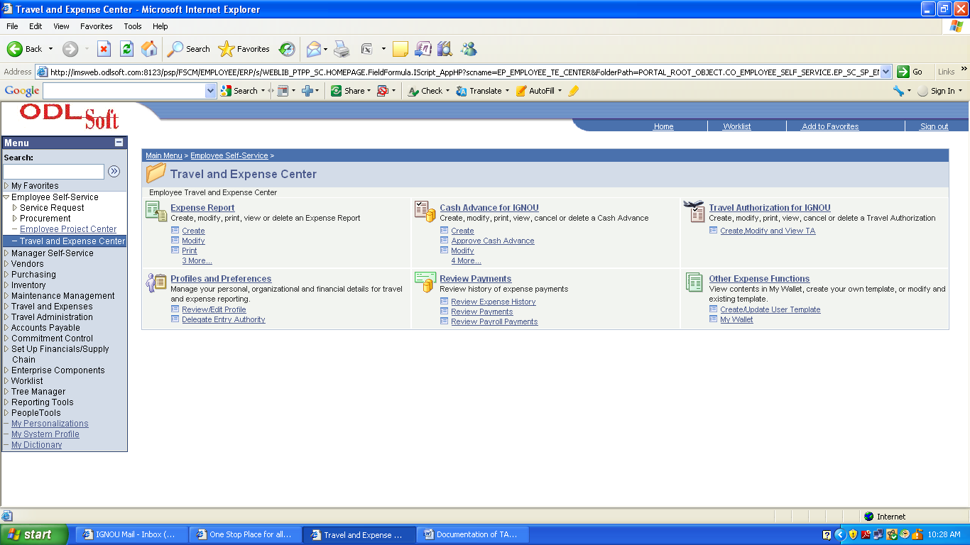

Step 2) Click on Create Modify and View TA Link in the Travel Authorization For IGNOU

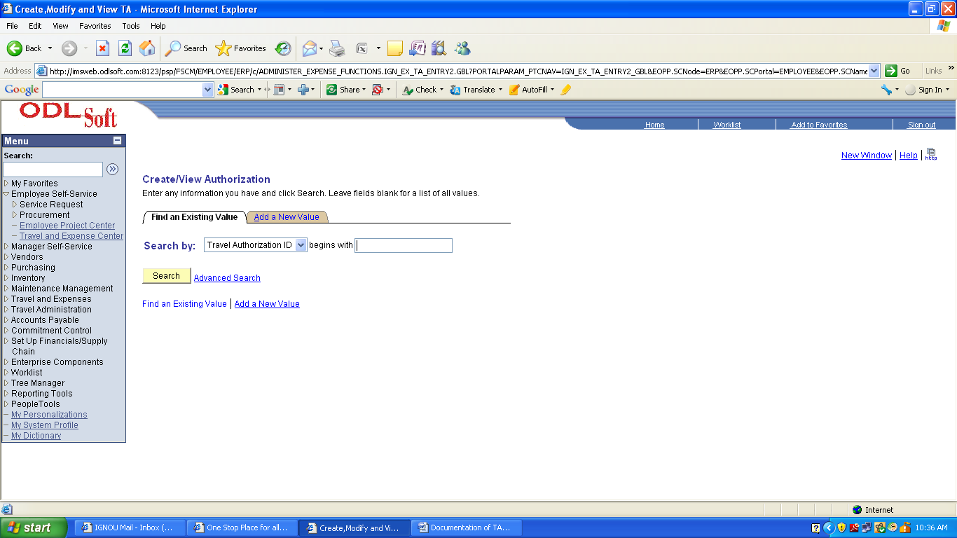

Step 3) Click on Add a New Tab Link

Following screen will follow

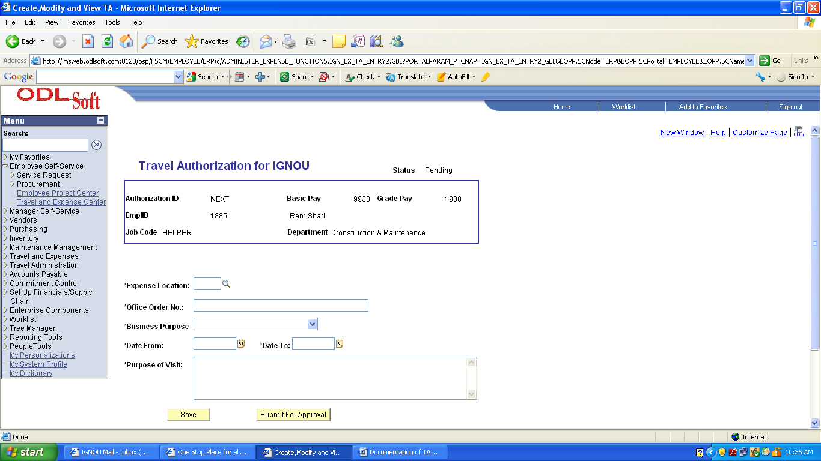

Fill the Following Information For Travel Authorization

- Expense Location → Location of the city where employee to be visited.If location not found then Specify OTH as location and specify the actual location in column of purpose of visit.
- Officer Order No. →Specify the Office order no.
- Business Purpose → Select the purpose of business as Domestic.
- Date From → Specify the Date Range of the visit
- Purpose of Visit → Specify the purpose of the visit

Step 4) Click on the Submit for Approval Button ,Unique Authorization ID is generated,the request will go the supervisior id of the respective employee.

Step 5) Follow the below link for Creation of cash advance (This can fill up prior to approval of Travel Authorization in the Odl system)

FSCM → Employee Self Service →Travel and Expense Centre → Cash Advance For IGNOU → Create

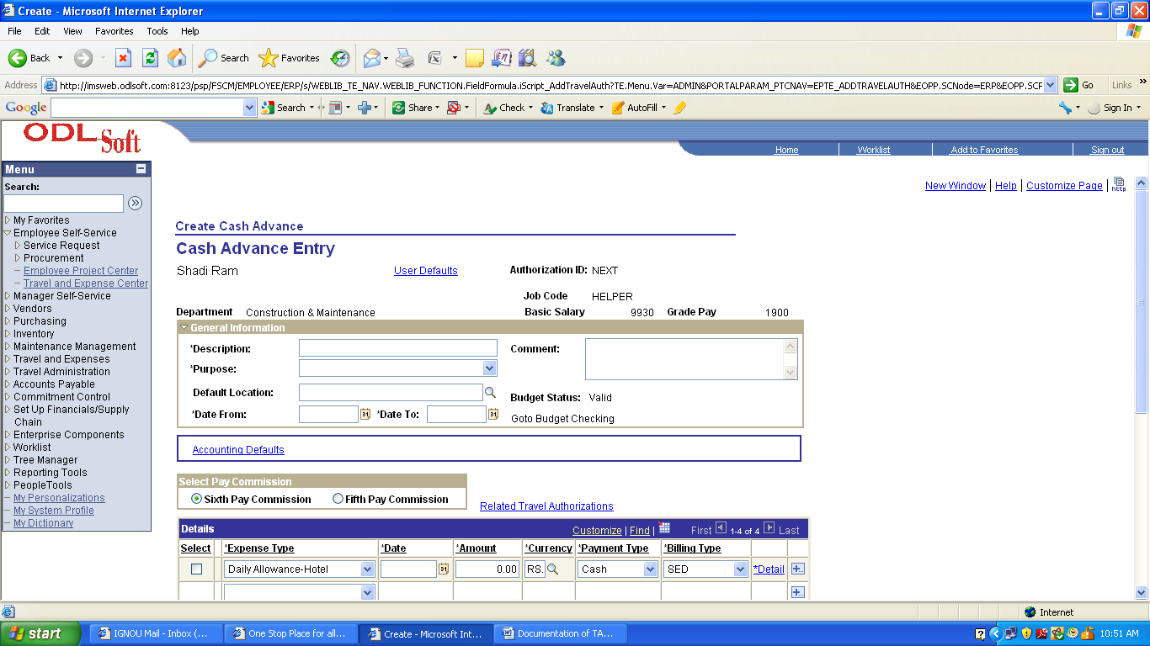

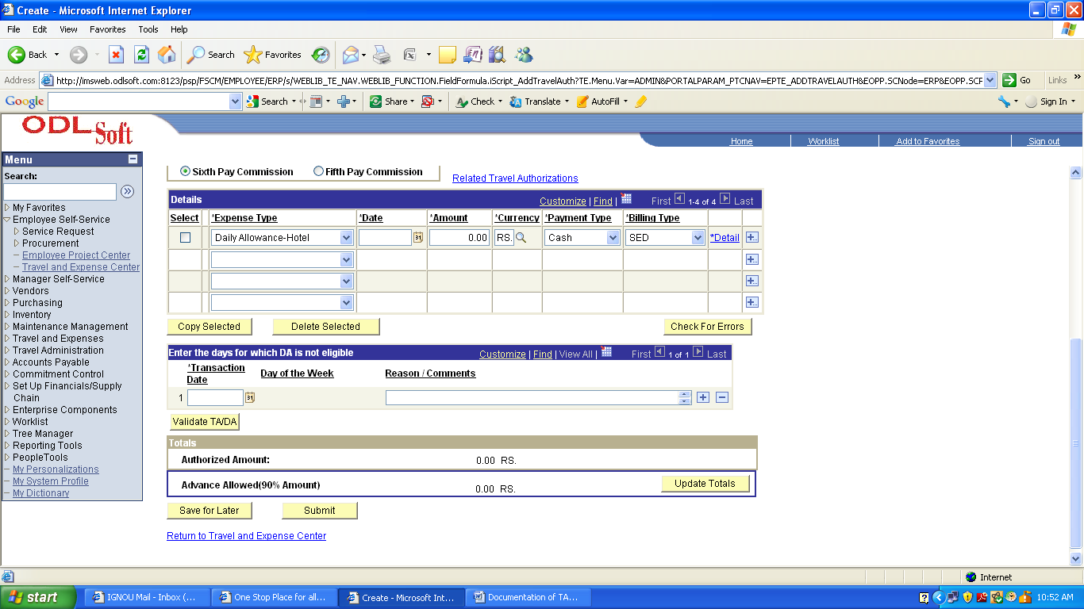

Step 6) Please Fill the Following fields for cash advance purpose

- Description → Please Fill the description for cash advance
- Purpose → Specify the purpose of Cash Advance as Official Tour Domestic.
- Default Location → Location of the city where employee to be visited.If location not found then Specify OTH as location and specify the actual location in column of purpose of visit.
- Date From → Specify the Date Range of the visit
- Select the Option Button “Sixth Pay Commission” under Select Pay Commission Heading
- Select the Expense Type(For Advance consolidated amount for Hotel,Food,Travel,etc can be filled up without giving time details)
- Select Billing Type as SED For OpenMAT Purpose.
- Click the Details Hyperlink For Start Date and End Date.
- Fill the Details of the Expense (Hotel,Food,Travel,etc)
- Click the Accounting Detail Hyperlink in the Detail Page.
- Fill the Account Field as AE0301011 and Division Filed as SED if its not been filled by the system.
12 Click Ok

Step 8) Click on the Return to Cash Advance For IGNOU

Step 7) Click on the Validate TA/DA Button

Step 8) Click on the Submit Button.

Step 9) Authorization ID in the Cash Advance page will be generated. Please Note Down the id.

Step 10) Follow the Below link for forwarding the Cash Advance Id to the next approver.

FSCM → Employee Self Service →Travel and Expense Centre → Cash Advance For IGNOU → Approve Cash Advance

Following Screen will appear.

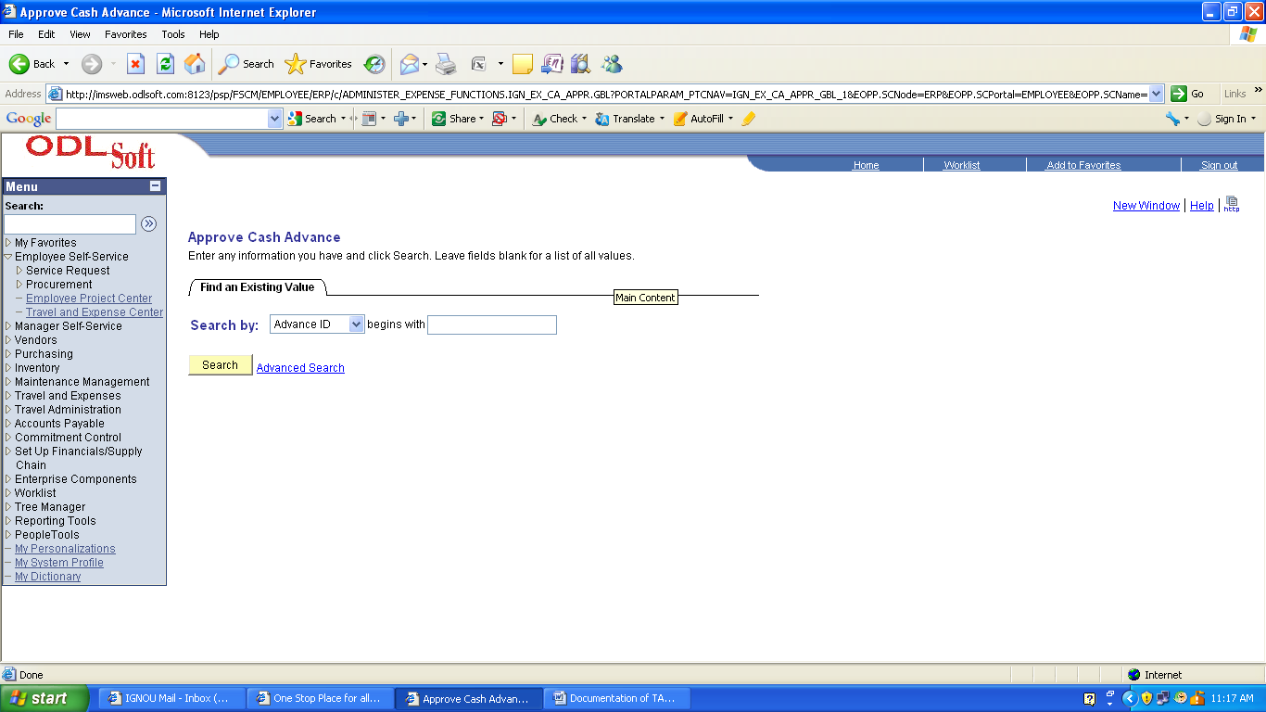

Step 11) Fill the Advance Id in the Advance Text Box. Click on Search.

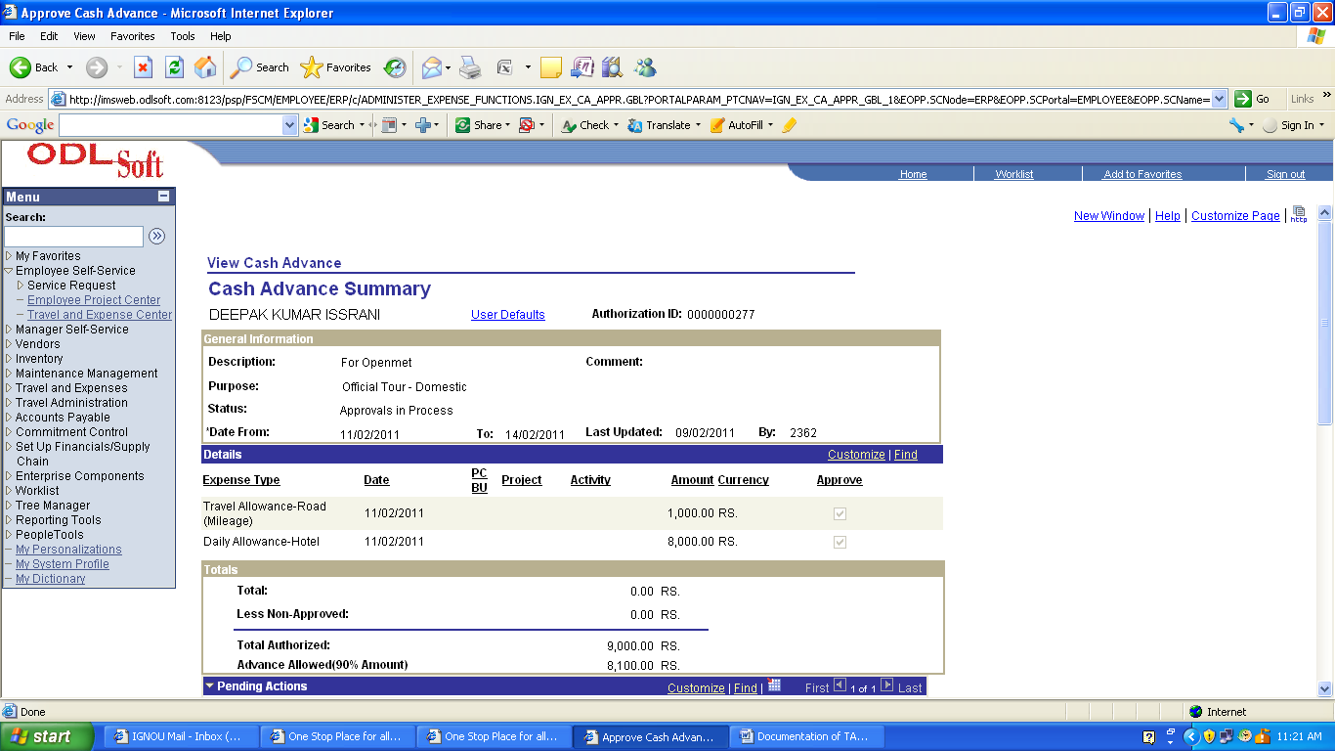
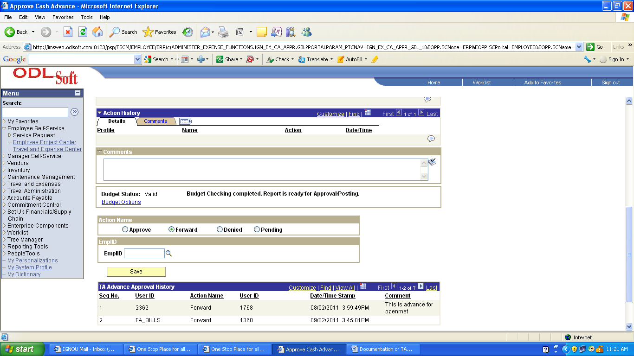

Step 11) Click the Forward Option Button and Fill the Employeeid in the Employee Text box.

Step 12) Click Save.

